Setting Up Development Environment

Topics:
- Installing Android Studio
- SDK (Software Development Kit) Setup
- AVD (Android Virtual Device) Setup
- Understanding Project Structure

1. Installing Android Studio
Android Studio is the official Integrated Development Environment (IDE) for Android app development, developed by Google. It provides tools for writing, testing, debugging, and packaging Android applications.
Steps to Install:
- Download Android Studio
  - Visit: https://developer.android.com/studio
  - Choose the version suitable for your operating system (Windows, macOS, Linux).
- Run the Installer
  - Follow the installation wizard and select components such as:
    - Android SDK
    - Android Virtual Device (AVD)
    - Android Command-Line Tools

- Complete Setup
  - Once installed, open Android Studio and let it download the necessary SDK files.
  - Accept all required SDK licenses.

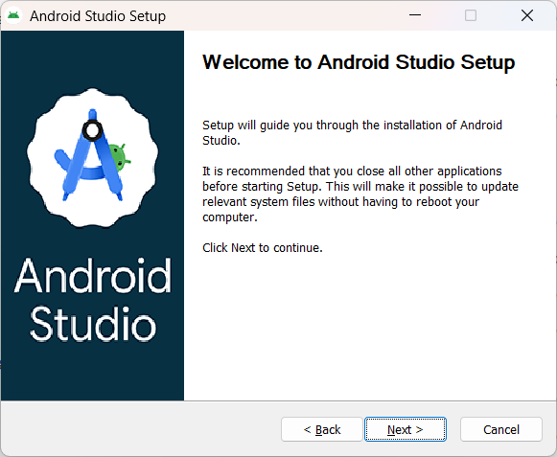

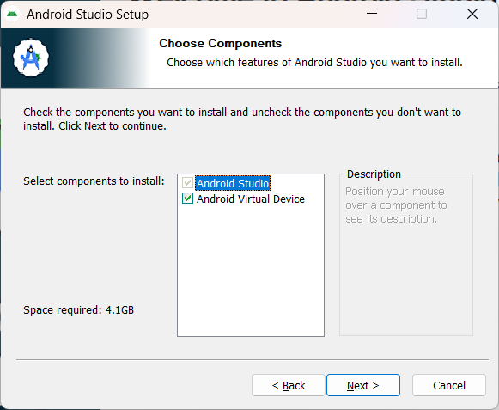

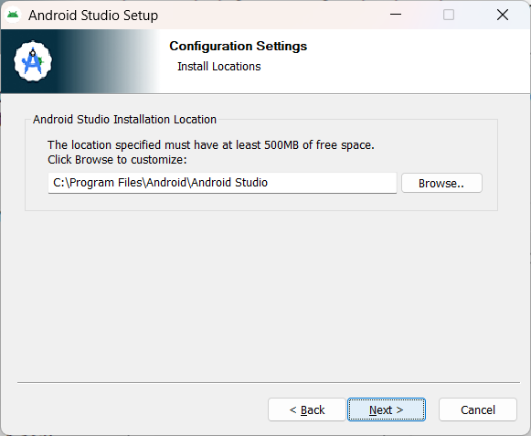

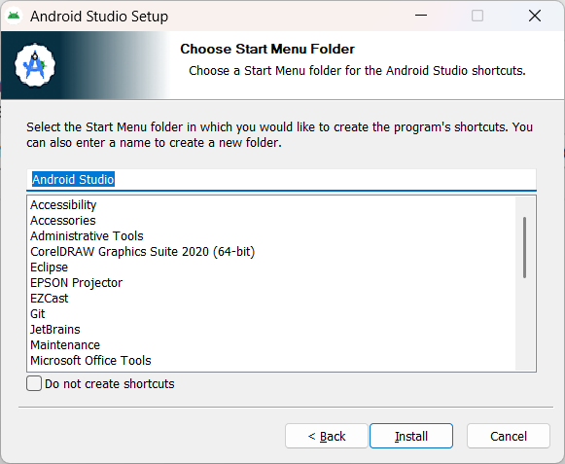

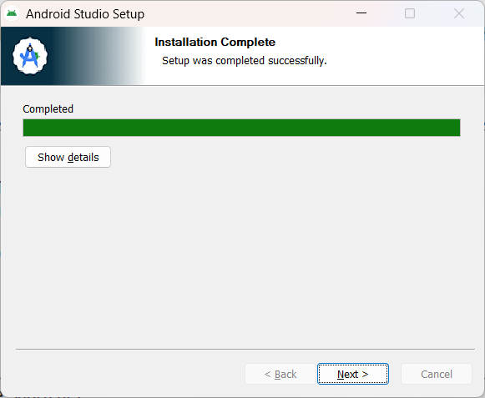

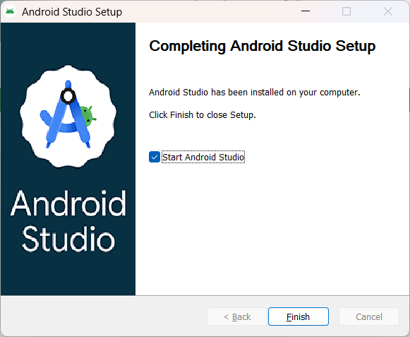

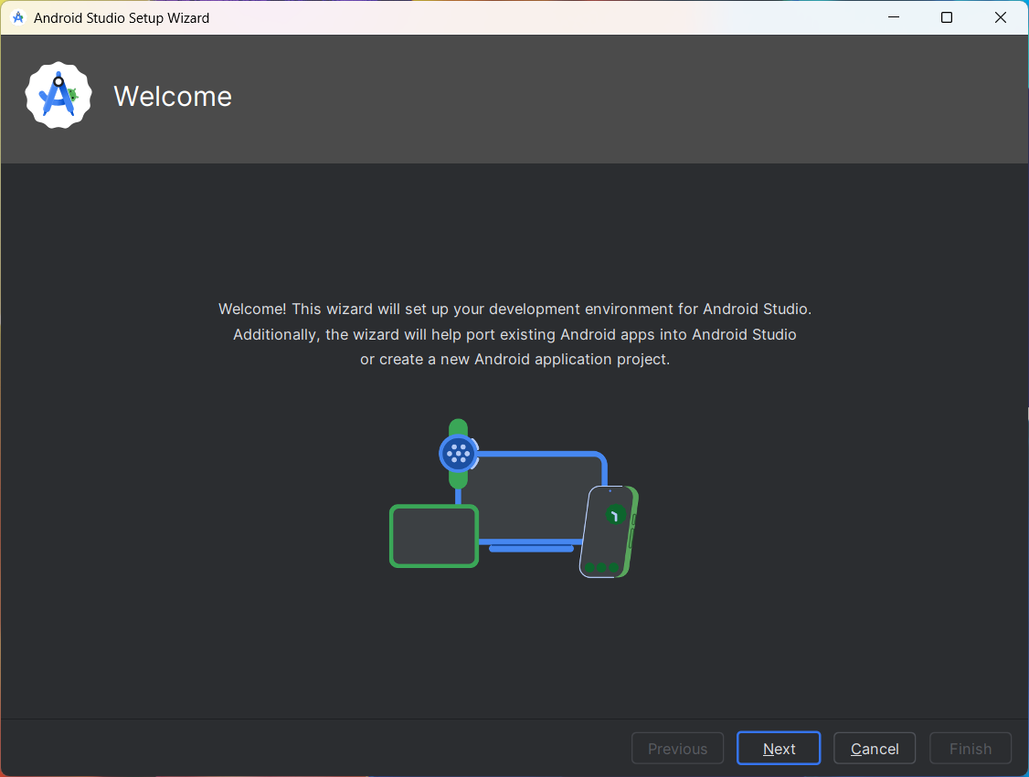

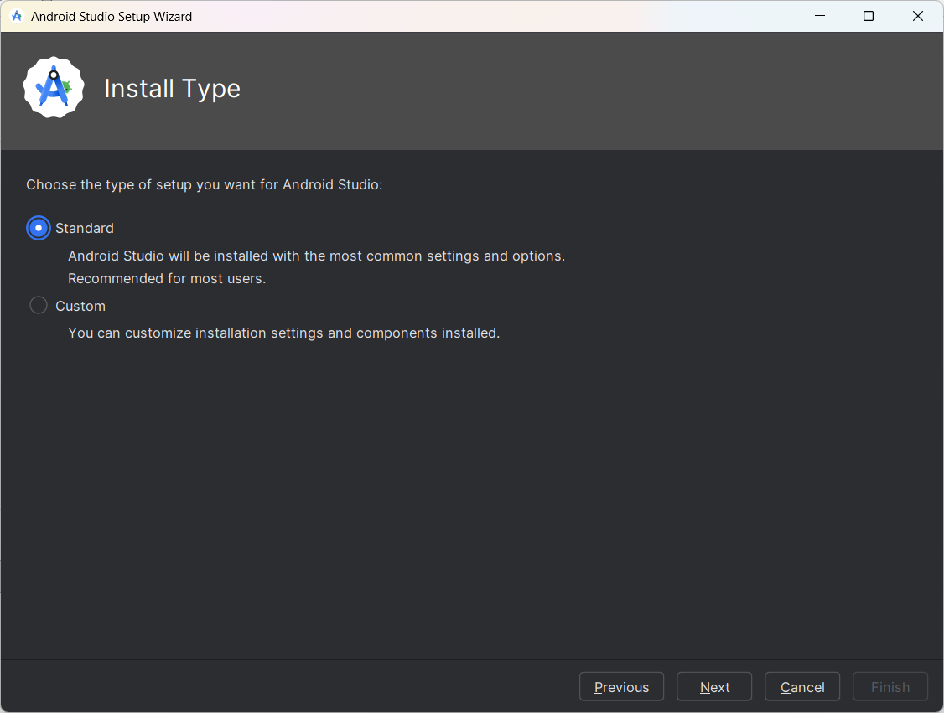

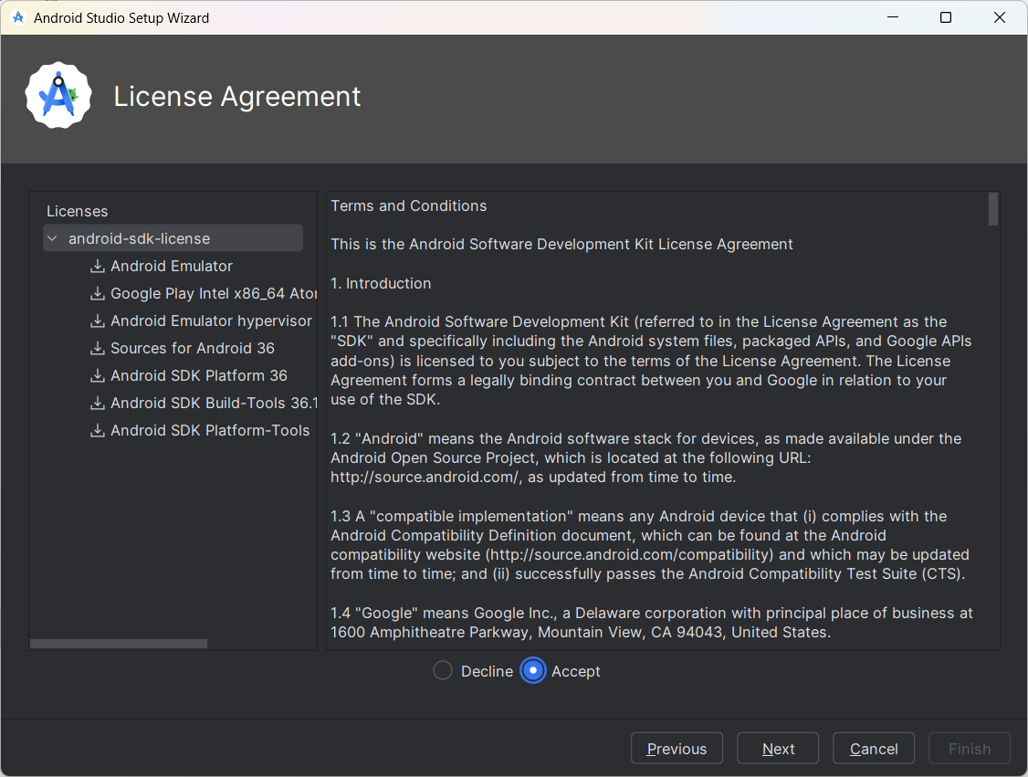

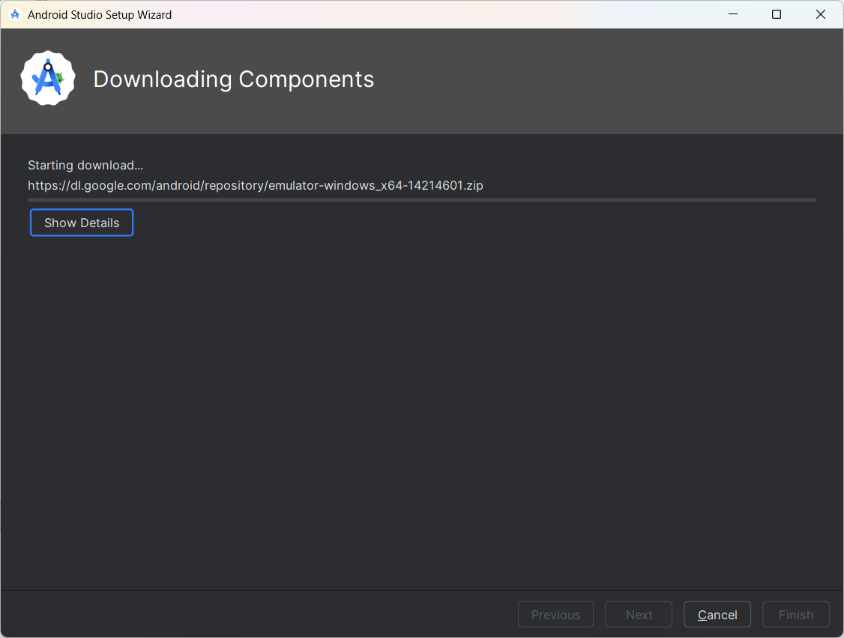

2. SDK (Software Development Kit) Setup
The Android SDK provides the libraries, APIs, and tools required to build and run Android applications.
Configuring SDK in Android Studio:
- Go to File → Settings → Appearance & Behavior → System Settings → Android SDK
- Choose the latest Android API level (recommended to have at least the last two stable versions).
- Select tools like:
  - Android SDK Platform
  - Android SDK Build-Tools
  - Android Emulator
  - Google USB Driver (if using a physical device)
- Click Apply → OK to install.

Purpose:
The SDK allows you to compile your app, test it on different Android versions, and access device features.

3. AVD (Android Virtual Device) Setup
The AVD Manager helps you create virtual devices (emulators) that simulate real Android phones or tablets.

Steps to Create an AVD:
- Open AVD Manager → Click Tools → Device Manager.
- Click Create Device → Choose a hardware profile (e.g., Pixel 7, Nexus 5).
- Select a System Image (like Android 13 or 14).
- Configure device settings such as orientation and memory.
- Click Finish, then Launch Emulator.
The emulator will start and display the Android home screen — just like a real phone.

4. Understanding Android Project Structure
When you create a new project in Android Studio, it automatically generates several important files and folders.

File/Folder | Description
app/ | Contains source code and resources
manifests/ | Holds AndroidManifest.xml (app configuration file)
java/ | Contains Kotlin or Java source code (activities, classes)
res/ | Holds UI layouts, images, strings, and icons
Gradle Scripts/ | Build configuration files (build.gradle)
MainActivity.kt | Main entry point for the app
activity_main.xml | Defines the layout of the main screen

This structure separates logic, design, and configuration for easier maintenance.

5. Running Your First App – “Hello World”
Once your environment is ready, you can create your first simple app.
Steps:
- Open Android Studio → Start a new project → Choose Empty Activity
- Select Kotlin as the programming language
- Click Finish
- The generated files include:
  - MainActivity.kt
  - activity_main.xml
- Click Run ▶️ to launch the app on the emulator.
- The app will display “Hello World!” on the screen.

Trainer Reference

Note:

Step-by-Step Fix for “No target device found”

1. Check if an Emulator (Virtual Device) is Set Up
- In Android Studio, go to:
Tools → Device Manager (or click the Device Manager icon on the toolbar).
- If no virtual device is listed, click “+ Create Device”.
- Choose a device (e.g. Pixel 4), click Next.
- Choose a system image (e.g. Android 14, API 34), download if needed.
- Click Finish to create it.
- Start the emulator by clicking the ▶️ Play icon next to it.
Now try Run ▶️ MainActivity again — it should detect and use this virtual device.

Learning Outcome
By the end of this session, you will be able to:
- Install and configure Android Studio successfully
- Set up the Android SDK and Virtual Device (AVD)
- Understand the structure of an Android project
- Build and run a simple “Hello World” application in Kotlin

